

Digigital design lab

Exp 2: Logic Gates







**Exp 2: Logic Gates**

**Objective** :

To study the **( AND,OR,NOT)** Gates and to realize Boolean equation for the Gates.

**Introduction:**

**Logic Gates:** Logic gate is an electronic circuit manufactured mainly as integrated circuit (IC) unites employing transistors, diodes, and other solid state components. Logic gates used to perform the AND, OR and inversion operations as well as two popular combinations of these two functions. Logic gate have one or more input terminals and one output terminal.

**Boolean Equations:** There are two useful techniques for reducing combinational logic equation and logic diagrams to the fewest possible elements. These two techniques are:

1. Mapping.

2. Boolean algebra.

**Required Devices** : KL-31001 digital logic circuit module KL-33002.

**Procedures:**

**(a). AND Gate Characteristics Measurement (Module KL-33002 block b)**

1. U2b and U2d of Module KL-33002 block b will be used in this section.

2. Connect inputs A, A1 to data switch SW0, SW1 on TTL level.

3. Make short between the points F2,A2 and A2,B2 according to figure(1-1).

4. Connect the output F4 to the logic indicator L0, then follow the input sequences in table (1-1) and record output F4.

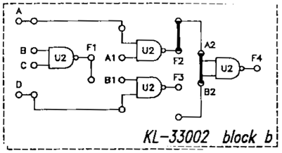

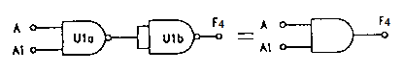

Figure(1-1).

Table(1-1).

|  |  |  |
| --- | --- | --- |
| INPUT | | OUTPUT |
| SW1(A1) | SW0(A) | F4 |
| 0 | 0 |  |
| 0 | 1 |  |
| 1 | 0 |  |
| 1 | 1 |  |

**(b). OR Gate Characteristics Measurement (Module KL-33002 block a)**

1. U1a and U1c of Module KL-33002 block a will be used in this section.

2. Connect inputs A, B to data switch SW0,SW1 on TTL level.

3. Make short between the points A1,B1 and F1,A1 according to figure(1-2).

4. Connect the output F3 to the logic indicator L0, then follow the input sequences in table(1-2) and record output F3.

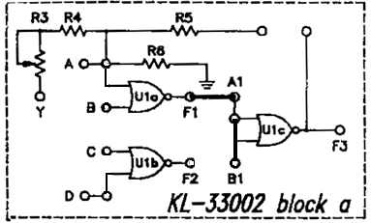

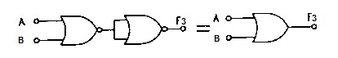

Figure(1-2).

Table(1-2).

|  |  |  |
| --- | --- | --- |
| INPUT | | OUTPUT |
| SW1(B) | SW0(A) | F3 |
| 0 | 0 |  |
| 0 | 1 |  |
| 1 | 0 |  |
| 1 | 1 |  |

**(c). INVERTER Gate Characteristics Measurement (Module KL-33002 block c)**

1. U4c of Module KL-33002 block c will be used in this section.

2. Connect input F3 and output F4 of U3c to SW0 and L1 respec­tively. Follow the input sequences in table(1-3) and record outputs.

Also, NOT gate can implemented by using one input NAND gate or one input NOR gate as shown in figure below.

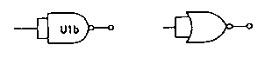

A

$$\overline{A}$$

$$\overline{A}$$

A

|  |  |  |
| --- | --- | --- |
| STATE | INPUT | OUTPUT |
|  | F3 | F4 |
| 0 | 0 |  |
| 1 | 1 |  |

**Discussion:**

1. What is a logic gate?

2. When does the NOT operation produce a high output?

3. When does the AND operation produce a high output?

4. When does the OR operation produce a high output?

5. What is an inverter?

6. Design logical circuit that satisfies the following equation after simplifying it ?

**F=ABC+AB+ACB**

7. Design a 3-input OR gate by using 2-input OR gates?